

**User Guide**

**Seda Assessments Tools’ Portal**

Table of contents

1. Introduction 4

2. Using the tools’ portal 5

2.1. Accessing the tools’ portal 5

2.2. Registering and managing user account 5

2.2.1. Registering User Account 6

2.2.2. Activating User account 8

2.2.3. Resetting Password 8

2.2.4. Viewing/Updating Account 9

2.2.5. Log into the tools’ portal 11

2.2.6. Log off the tools’ portal 12

3. The tools’ portal structure 12

3.1. Basic assessment tools 12

3.2. Advanced assessment tools 13

3.3. Navigating the tools portal 13

3.3.1. Using menu items 13

3.3.2. Using icon links on the default page 14

4. Listing clients and businesses 15

4.1. Listing registered/assigned clients 15

4.2. Searching client on the clients’ list 17

4.3. Listing registered/assigned businesses 17

4.4. Searching a business on the businesses’ list 18

4.5. Listing & searching assessments 18

5. Accessing and using the assessment tools 21

5.1. Selecting an assessment tool 21

5.2. Search for a particular assessment 22

5.2.1. Search assessment from a tools’ home page. 22

5.2.2. Search using the assessments search page. 23

5.3. View/edit details of an assessment 24

5.4. Registering a new assessment 24

5.5. Assessment Processes 25

5.6. Assessment Processes Explained 26

5.6.1. Register/Initiate the assessment 26

5.6.2. Complete (or edit) the assessment questionnaire sections 26

5.6.3. Submit the assessment for reviewing by the Branch manager (BM) 27

5.6.4. Upload Final Report 27

5.6.5. Submit the Final Report (Close assessment) 28

6. An assessment sample 28

6.1. Register/initiate a new assessment 28

6.2. Completing assessment questionnaire 31

6.3. Completing the main questionnaire 33

6.4. Recommendations 33

6.5. Action Plans 34

6.6. Submitting assessment for review by the Branch Manager 35

6.7. Uploading the Final Report 40

6.8. Submitting the Final Report 41

7. Individual Assessments 43

7.1. Business Idea Assessment Tool (BIA) 43

7.1.1. Carrying out a BIAT assessment 44

7.2. The Pre-Startup Assessment Tool (PST) 49

7.2.1. Carrying out a PST assessment 50

7.3. The Entrepreneurial Diagnostic Tool (EDT) 54

7.3.1. Carrying out an EDT assessment 56

7.4. Export Readiness Assessment Tool (ERAT) 60

7.4.1. Carrying out an ERAT assessment 62

7.5. Small Business Assessment Tool (SBAT) 66

7.5.1. Carrying out a SBAT assessment 67

7.6. Assessment Of Company Operations (ACO) 72

7.6.1. Carrying out an ACO assessment 73

# Introduction

The SEDA tools portal is a web-based application consisting of different tools that are used by SEDA practitioners to assess different aspects of a business, in order to deduce the most appropriate advice for the participating client/business, on how best to either start the business, sustain the business, venture or diversify into certain markets.

The tools portal has a total of eight tools that are all usable to a registered, authorized user.

Currently, the tools portal is only accessible internally from the SEDA data infrastructure, hence can only be available to a user who is connected to the SEDA network, either directly using physical Ethernet or virtual connection facilities.

This manual aims to guide users on how to quickly navigate the tools portal and each individual tool.

# Using the tools’ portal

## Accessing the tools’ portal

The tools portal is accessed through any web browser software like Microsoft Edge, Google Chrome, Firefox and others.

To access the tools portal, simply type the address 10.64.0.48:84 on the browser, and press the [Enter] button. Please note that the give address above may change from time to time, if the portal is published on another server/port. The new address will always be communicated by the responsible department within Seda.

Once the above address is typed in the browser, the portal login screen will appear as below:

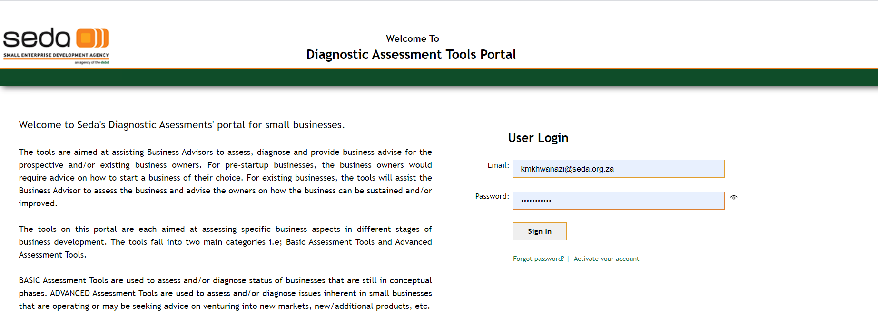

## Registering and managing user account

In order to use the tools portal, a user will need to have a registered and activated account on the tools database.

The tools portal is linked with the Seda’s CRM system, so much that a user will need to be registered on the CRM system before they can activate their account on the tools portal.

## Registering User Account

To register account, from the tools’ login screen, click on the “**Activate your account**” link. The account registration form will appear as indicated below:

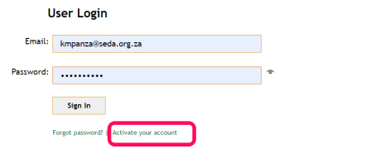

1. Enter your official Seda email as registered in the CRM system. **Only valid Seda emails will be accepted**

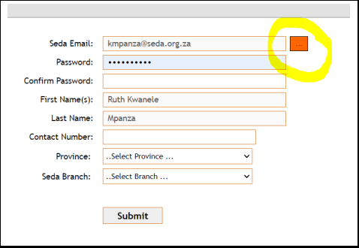

1. Click on the “Verify email on CRM” button (highlighted in the illustration above). This will check if the supplied email exists in the CRM, and if the email is already registered in the tools portal database.
2. If the email exists in the CRM, the system will pull other details from the CRM, mainly the user’s First name and surname and displays them as indicated.

Note that the user’s first and last names cannot be edited in the tools’ portal, this can only be done through the CRM. This is the reason why they appear disabled on the registration form

1. Enter the rest of the details as indicated, and click the “Submit” button to save
2. If the save is successful
3. You will be directed to a page with a congratulatory message as below.

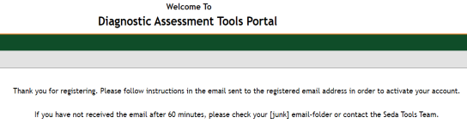

1. An email message will be sent to the email address provided on the registration. The message will have instructions on how you should activate your account, as indicated below:

Good day

Thank you for registering as a user on the Seda tools portal. In order to activate your account, please click on the link below:

http://10.64.0.48:84/ActivateAcc.aspx?Auth_User_ID=655&passType=1

If you are having problems activating your account, please contact Seda Tools Team.

Regards  
  
The Seda Tools Team

## Activating User account

After registering an account as explained above, the account will need to be activated.

To activate an account, in the message that has been sent to the registered email, click on the supplied link. The system will open an activation page where the activation is automatically done.

On successful activation, the system will display the message below:

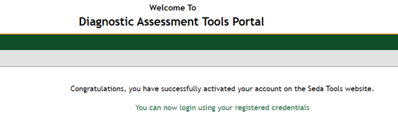

## Resetting Password

In the case of a forgotten password, follow the steps below to reset the password:

1. On the login screen of the tools’ portal, click on the “**Forgot password**” link
2. A password re-set form will be displayed as indicated below:

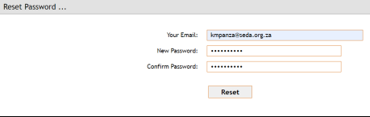

1. Enter the details for displayed 3 fields and click the “Reset” button
2. If the reset was successful, the system will display a message and send an email to the supplied email address, with instructions to activate the account
3. Click on the link supplied in the email to activate the new password.

## Viewing/Updating Account

User can view and edit the passwords even without forgetting the password. To edit some of the account details, follow the procedure explained here:’

1. Log into the tools’ portal using the current credentials
2. On the screen displayed after logging into the portal, click on the “**Account**” link that appears on the menus on the top-right corner of the screen, as highlighted below:

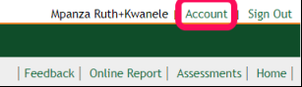

1. On clicking the “Account” link, the system will display a form with account details. Proceed to edit the account details as required and click “Submit” button to save

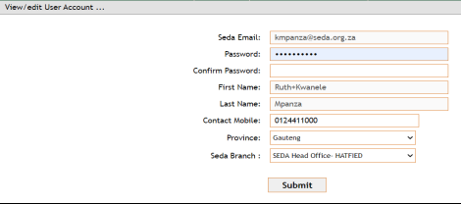

1. If submit was successful, a notification email will be sent to the supplied email again for activation. Click on the link supplied in the email for system to automatically activate account.

**Account Activation Email**

Good day

Thank you for registering as a user on the Seda tools portal. In order to activate your account, please click on the link below:

http://10.64.0.48:84/ActivateAcc.aspx?Auth_User_ID=655&passType=1

If you are having problems activating your account, please contact Seda Tools Team.

Regards  
  
The Seda Tools Team

## Log into the tools’ portal

To log into the tools’ portal, supply the user-email and the password as registered above, in the indicated text-boxes.

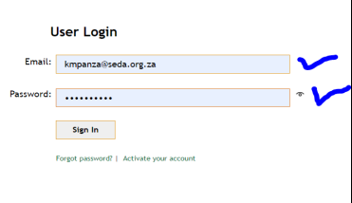

The page that will be opened next depends on the user’ level of authority, being a Business Advisor/Practitioner or Branch Manager.

If the user is a Business Advisor, the system will navigate to a default Home page of the tools as show below:

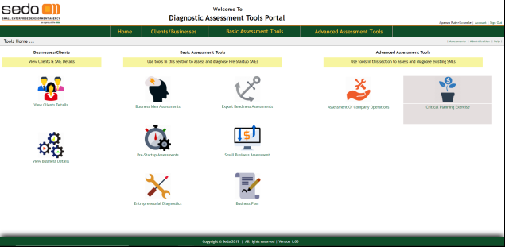

## Log off the tools’ portal

To logout of the tools’ portal, simply click on the “Sign Out” link that appears on the top-right corner of the screen when a user is logged.



This will close any active user sessions and navigate to the login screen.

# The tools’ portal structure

The tools portal consists of 8 tools in total, and 2 facilities to list registered clients and registered businesses. The tools are classified as “Basic Assessment Tools” and “Advanced Assessment Tools”

## Basic assessment tools

Basic Assessment Tools are used to assess businesses on day to day, more common and specialized aspects of a business.

1. Business Idea Assessment Tool (BIAT)
2. Pre-Startup Assessment tool (PST)
3. Entrepreneurial Diagnostic tool (EDT)
4. Export Readiness Assessment tool (ERAT)
5. Small Business Assessment Tool (SBAT)
6. Business Planning tool (BPT)

## Advanced assessment tools

Advanced assessment tools are more specific and seek to deduce some path of an aspect being assessed. These include

1. Assessment Of Company Operations tool (ACO)
2. Critical planning Exercise (CPE)

## Navigating the tools portal

There are 2 ways of navigating to each tool and other facilities of the tools’ portal, which is

## Using menu items

These will appear on each and every page that the user navigates to when they are logged to the tools’ portal.

This means its possible to directly navigate to the page of each and every tool from each page of the portal. Menus will be displayed dynamically at the top of each page as illustrated below:

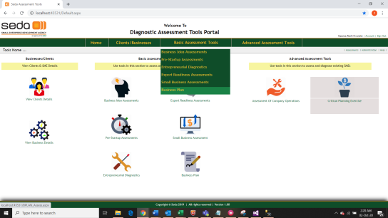

## Using icon links on the default page

Icons representing each tool can also be used to navigate to a particular tool. Icons only appear on the portal’s home page and nowhere else on the portal as indicated below.

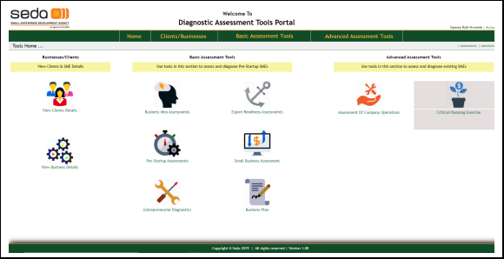

# Listing clients and businesses

The essence of the tools’ portal is to enable the Business Advisors/Practitioners to carry out assessments for each business that belongs to a client (applicant)

This means that before an assessment can be carried out, the client/business must be registered first.

Clients and their businesses are registered in the CRM system. The tools portal does NOT have a master repository for the 2 entities, but only keeps and tracks data strictly related to the assessments’

## Listing registered/assigned clients

To view clients that can be assessed by a Business Advisor/Practitioner, click on the “View Clients Details” on the home page or from the main menu.

This will navigate to a page where clients/applicants are listed, using the following algorithm:

- If the user is a Business Advisor/Practitioner, only clients that are assigned to him or her are listed

- If the user is a Branch Manager (BM), clients assigned to all the Business Advisors/Practitioners at that branch are listed

- If the user is a provincial Manager, all clients registered for users in that province are listed

- If the user is a national authority, they will see all the clients registered in the entire CRM database

The illustration below shows a sample list of clients for currently logged user (highlighted)

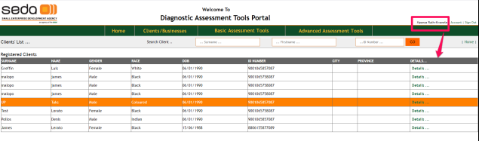

To drill-down into an individual client’s details, click on the “Details …” link that appears on the right-most column of the list, alongside the required client record. This will pull basic data related to the client and display it in the form as illustrated below.

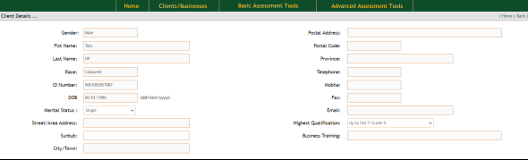

Please note that client’s details cannot be edited in the tools’ portal. This function is done in the CRM where the clients are registered.

## Searching client on the clients’ list

It is possible for a user to search for a particular client from the displayed list.

A client can be searched using either or all of their Surname, First names and/or ID number

Simply enter the parameter of the clients being searched and click the “GO” button.

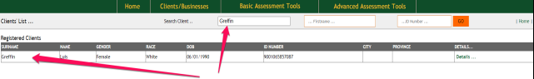

After running a search, in order to restore the records filter to the original “all records” state

- Remove the previously entered parameter/s

- Click the “GO” button

- The list of clients based on the algorithm explained above will be displayed.

## Listing registered/assigned businesses

Businesses can also be listed in the same way as clients, by clicking the “View Business Details” from the home page or through the drop-down menu items under “Clients/Businesses”. The illustration below shows the sample list of businesses for the current user.

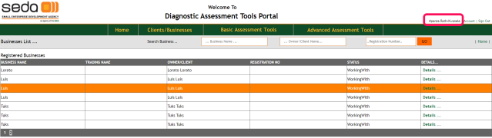

As with clients’ list, the businesses listed by default will be in the following categories:

- Businesses belonging to clients allocated to the current user, if user is a B/A or practitioner

- Businesses belonging to all users at the particular branch if the current user is a Branch Manager

- Businesses belonging to all users in the province if the logged user is a provincial manager

- All businesses registered for all clients in the entire CRM database, if the current user is a national authority

## Searching a business on the businesses’ list

A user is also able to search for a business from the listed businesses. A business search can be done using the following attributes of the business:

- Business name

- Business owner’s name

- Business registration number

Enter any or all of the parameters to search for the business and click on the “GO” button. If the business matching the entered criteria exists, it will appear on the filtered list of businesses as illustrated below:

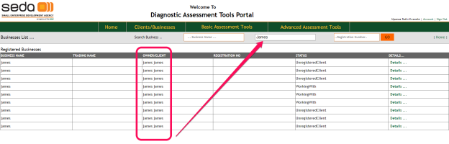

## Listing & searching assessments

The tools portal makes it possible to list and search for particular assessments, even without navigating into the individual tools themselves.

To do this, from the portal’s home page, click on the “Assessments” link as indicated in the illustration below:

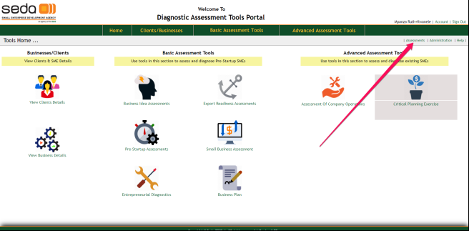

On clicking on the Assessments link above, the portal will navigate to the “Assessments” page, as indicated in the illustration below:

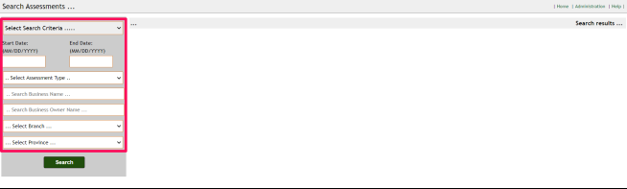

The assessments page consists of 2 main sections:

1. Section that contains several options that will be used to specify the Searching criteria
2. Section used to display the filtered set of assessments, depending on the selected and specified criteria above.

To list a set of assessments, follow the steps:

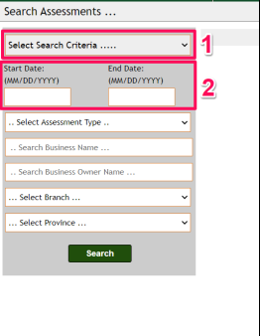

1. Select the Search Criteria in the drop-down indicated “Select Search Criteria ..” – 1
2. Select or specify the dates of the assessments i.e when the assessments were initially captured
3. Depending on (1) above, the rest of the fields to be specified will be enabled/disabled accordingly
4. Supply the data for each enabled field thereof
5. Click the “Search” button
6. If the specified criteria match some fields of some assessments they will be displayed, as indicated by a sample cripple criterion below.

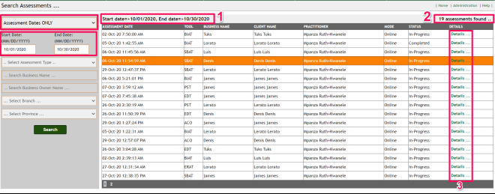

In the illustration above:

1. Indicates the selected/specified criteria and filter
2. Indicates total number of assessments that matched the specified criteria
3. Using the “Details…” link, user can navigate directly to the assessment

# Accessing and using the assessment tools

There is a total of eight assessment tools on the tools’ portal. Each one is used to assess different aspects of a business.

## Selecting an assessment tool

To select an assessment tool, follow the procedure below:

1. From the tools’ home-page, or from the main menu items, click on the required tool
2. This will navigate to the particular tool’s home page, where existing assessments are listed, with such details the assessment number, business assessed and its owner, assessment dates and current assessment status.
3. On this page, user can do the following actions related to a certain assessment:
   * Search for an assessment
   * Enter a new assessment
   * Go to details of a particular assessment

All the assessments that will show in the assessment’s home page are filtered with the algorithm:

1. If user is a BA/Practitioner, only assessments that the current user registered for that particular tool will be displayed
2. If the user is a BM, only assessments registered/performed by users of the current branch, on the particular tool are displayed
3. If user js a P/A, all assessments registered/performed by users in that province, for the particular tool are listed
4. If user is a national authority, all assessments for the particular tool I the entire database are listed

## Search for a particular assessment

There are two main ways by which an ordinary user may search for certain assessments. User may search an assessment directly from the particular tool’s home page, or may use the more comprehensive assessments’ search page.

## Search assessment from a tools’ home page.

1. Go to the home-page of the tool
2. Provide any of the parameters indicated in the “Search bar” as illustrated below:
3. Click the “GO” button
4. Is the assessment matching the specified parameters exist, it will be filtered and displayed in the new list.

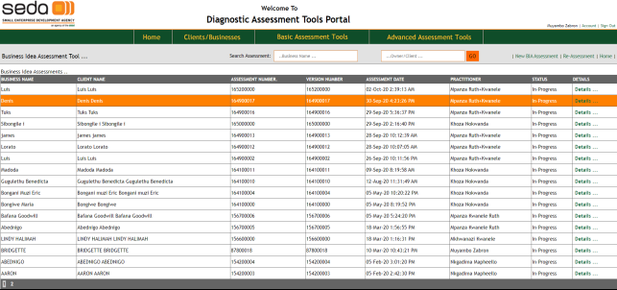

## Search using the assessments search page.

From the main tools home-page (default) click on the “Assessments” link, indicated below:

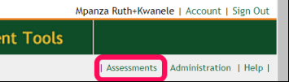

The system will navigate to the Assessments search page, shown in the illustration below.

On this page user can select required criteria to search for their assessments, from the left pane section (marked 1)

If specified match is found, the system will display a summary of assessment records found (marked 2) as well as the total number or the assessments found matching the criteria (marked 3)

User can go to the assessment by clicking on the “Details ..” link-button that appears on the right-most column of the record row.

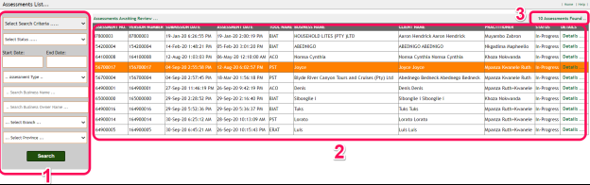

## View/edit details of an assessment

To drill-down a tool’s details, click on the “Details …” link alongside each assessment record on the particular tool’s home page.

## Registering a new assessment

To register or initiate a new assessment, form the “Search bar”, click on the “New ???? Assessment” link; with ??? being the tool name, for example “New BIA Assessment”

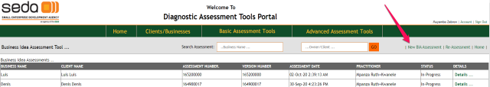

## Assessment Processes

Although the tools are different, there are common trends that need to be followed when carrying out an assessment. The illustration below shows the general assessment processes from beginning to the end.

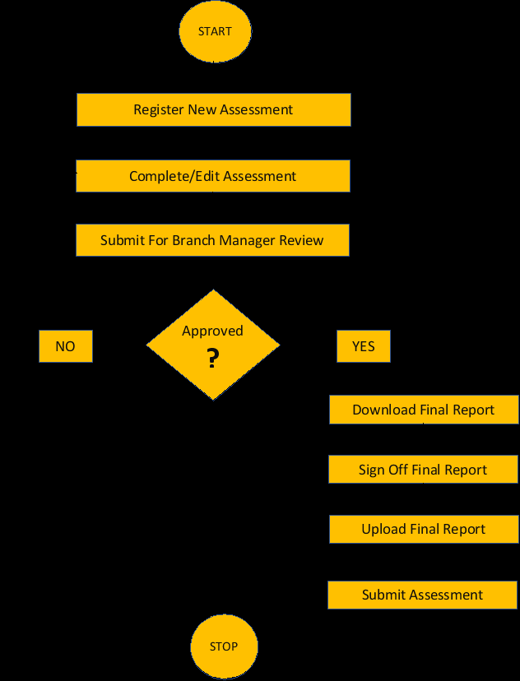

## Assessment Processes Explained

In this section, we explain in detail, the generic flow of processes in a typical assessment. The tools will different in content but the process flows below will always be the same

## Register/Initiate the assessment

This is the first process in undertaking a new assessment, and is done in a similar way for each assessment.

In this process, the assessment’s identification data is captured. This data includes:

1. The client whose business is being assessed
2. The business (may be among many for a particular client) being assessed
3. The names of interviewees giving responses to the questionnaire/s

Once registered, an assessment maybe completed in either a single or multiple sessions before it is submitted for review.

## Complete (or edit) the assessment questionnaire sections

Each assessment contains a different number and formats of questionnaire, although some sections and attributes maybe similar.

In this second phase of the assessment process, all the sections must be completed before the next process, submitting for review.

Completing the questionnaires can be done in any order.

Once a section is complete, the system will mark the bullet with a tick-mark, replacing original green disk bullet.

The “Review/Submit Assessment” panel also appears underneath the assessment questionnaire panel, with the “Submit For Review” caption.

## Submit the assessment for reviewing by the Branch manager (BM)

Once all sections of the questionnaire are completed, the assessment can be submitted for reviewing by the Branch Manager

When the Branch Manager reviews the assessment, it will be marked as either a “Re-work” indicating the Business Advisor must go back and research on a certain response, or it will be marked as Approved, so it can go to the next phase.

The assessment review cycle will be carried out in cycles with each review/feedback cycle being communicated by emails.

If the assessment is in the BA’s “in-tray”, the assessment button will indicate this by a “Submit For Review” caption.

If the assessment is in the BA’s “out-tray”, it will indicate by the “Review Pending” caption

## Upload Final Report

If approved in the “Review/Submit” section, the user needs to attached the signed, final report that may be retrieved when required. To achieve this, the system will reveal another panel, the “Attach Final” report panel.

The user must download the final report so that it can be signed by relevant authorities. Downloading a report can be done either through the “Online Report” or “Feedback” links.

To upload the signed final report:

* Click on the file-upload facility to display the file-dialog popup.
* Select the report file
* Click on the Upload report button; report will be uploaded
* The “Final Report” caption in the questionnaire sections panel will be ticked by a green tick mark, replacing the green disc

## Submit the Final Report (Close assessment)

The final process is closing of the assessment.

When the final report is uploaded, the system will display another panel “Submit Assessment”, with a command button captioned “Submit Assessment”

1. Click on the “Submit Assessment” button
2. System will pop-up a confirmation box to ascertain if user is certain of the pending action
3. On selecting “Continue”, the system will tag the assessment as “Assessment Submitted”
4. At this point, the assessment cannot be edited and neither will it accept another final report to be uploaded

**The assessment cycle ends here!**

# An assessment sample

In this section, we will take a practical example of a typical assessment, step by step. Please note that the only difference among assessment tools is just the types of sections that they will have, but all processes will be the same as described above.

This sample will be explained using the Business Idea Assessment tool (BIAT)

## Register/initiate a new assessment

1. From the tools main home-page, click the “Business Idea Assessment” tool’s link

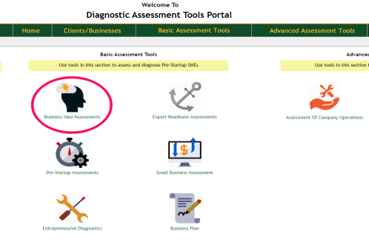

1. The system will navigate to the Business Idea Assessment tool’s home page as indicated below. If the current user registered other assessments of this tool before, they will appear listed too.

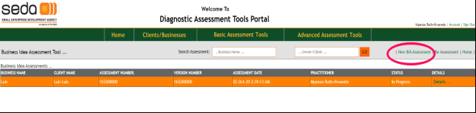

1. Click on the “New BIA Assessment” link on the far-right side of the “Search” bar, as illustrated below:
2. Once the “New BIA Assessment” link is clicked, the system will navigate to a new form where a new assessment will be registered. Initially, only the “Client Name” will appear on the form as shown below.

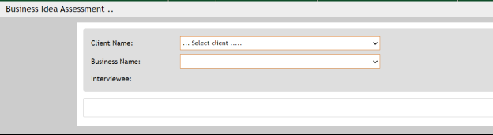

1. Click on the “….Select client …” dropdown-box to list all ***clients assigned to current user in the CRM***
2. Once the client is selected, all businesses registered under the selected client will appear filtered in the “Business Name” drop-down box
3. Select the business to be assessed
4. Enter the name/s of the interviewee/s for this assessment

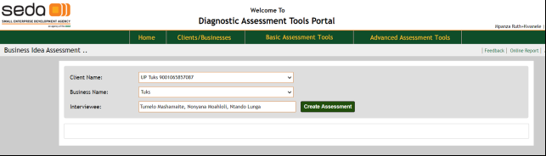

1. Click on the “Create Assessment” button
2. The assessment will be registered and a message – “Assessment has been initiated ...” will appear on the same form as indicated by 1. In the illustration below.
3. At this point too, the bottom/details part of the assessment will be shown, exposing the detailed sections of the assessment as illustration below indicates.

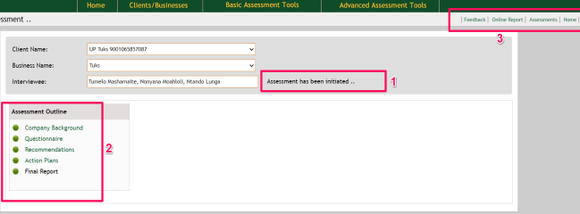

Each assessment has 2 distinct set of links, which are:

* Questionnaire section links indicated by 2 in the illustration
* Miscellaneous links indicated by 3 in same illustration above

## Completing assessment questionnaire

As mentioned in sections above, each assessment type may have different sections of its questionnaire although some sections may be common in some or all of the tools.

To complete the questionnaire:

1. Open Company background by clicking “Company Background” link on the links that appear on the left, indicated by 2. The popup window shown below will be displayed.
2. Enter a summarized brief of the company’s background
3. Click on the “Save” button to update the background.

NOTE:

The company background, like any other part of the questionnaire, is editable so long as the assessment is not yet approved.

Once an assessment is approved, no part of the questionnaire is editable.

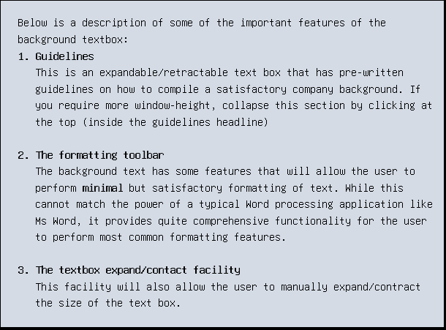

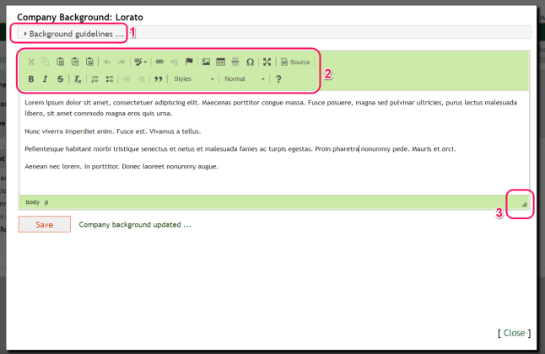

## Completing the main questionnaire

The questionnaire is the main part of the assessment and it contains a set of questions in different categories.

To complete and save responses, you will be required to enter ALL the questions in the questionnaire

1. Click on the “Questionnaire” link from the section links on the left
2. The questionnaire will be displayed, either on the main assessment area or as a popup window.
3. Complete the questionnaire as is necessary, while saving the data

## Recommendations

The recommendations window will also appear as a pop-up window.

The popup window appears also with an amateur tool-bar with facilities used to perform minimal but equally sufficient formatting of the entered text.

1. Enter the recommendations and save with the “Save” button

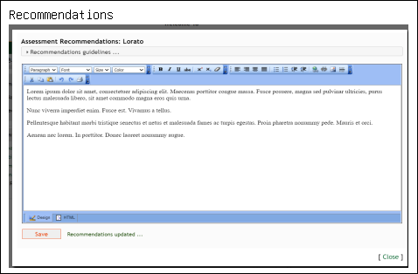

## Action Plans

1. To add an action plan, click on the “Action Plans” link. A popup window with action plan fields will appear as below:

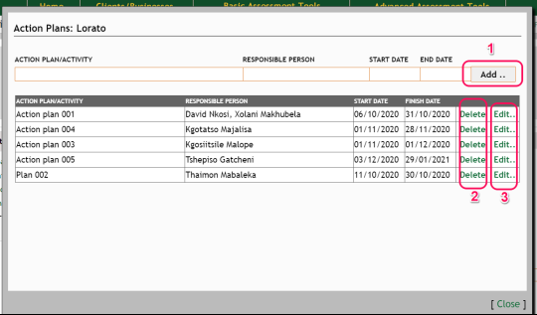

* Complete the indicated fields with relevant data related to each action plan
* Click the “Add ..” button (indicated as 1) to save the action plan and its attributes. The action plan will immediately appear in the action-plans list box below, as indicated in the illustration
* To delete an action plan, click the “Delete” button (in column 2) alongside the action plan
* To edit the action plan, click the “Edit ..” button (in column 3) alongside the action plan. This will display the action plan attributes in the data-entry text boxes. Edit the action plan as required and click the “Save” button

## Submitting assessment for review by the Branch Manager

On completion of each section, the green disc bullets will turn into a green tick-mark, indicating that the section has been completed. All discs until the “Final Report” must be ticked, as indicated below.

At this point the assessment will be ready to be submitted to the Branch Manager for a review.

A new section below the main questionnaire section links will appear, the “Assessment Review/Submit” section. Initially the button “Submit For Review” will be shown, as indicated in the illustration below:

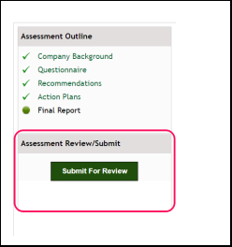

1. Click on the “Submit For Review” button. The following will happen:
2. The system to flag the assessment into “Review Pending” mode
3. An email notification is sent to the Branch Manager to review the assessment.

On navigating to the same assessment, the button will be showing that it is in “Review Pending” mode, as indicated below:

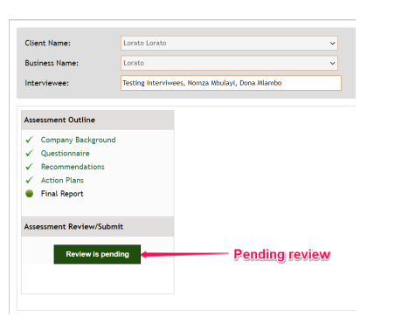

1. Once the Branch Manager submits the feedback, the user (Business Advisor/Practitioner) will receive an email notification to the effect that the assessment has been reviewed. Email sample is shown in the illustration below:

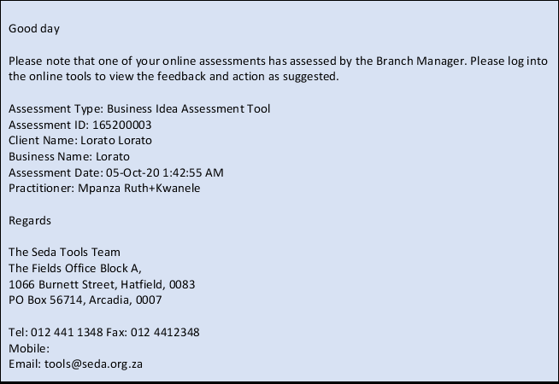

1. To view the review message:
   * Log into the tools and navigate to the assessment
   * Click on the “Feedback” link
   * A review popup window will be displayed as indicated below, bearing the following features:
2. Assessment report, on the left pane marked with (1)
3. Review content from the Branch Manager indicated with (2)
4. List of reviews (if any) on the far-right pane, indicated by (3).

**Please note here that there can be more than one review to an assessment.**

* Click on the latest feedback listing and the contents will appear on the review content panel (2).
* Also note here the caption displayed on the “Review/Submit Assessment” button:

If the verdict issued by the B/A is “Re-Work”, the caption will be “**Submit For Review**” implying that the user need to work on some highlighted issues and re-submit to the B/A for a further review.

In this case, the assessment will go through the cycle again until it is approved.

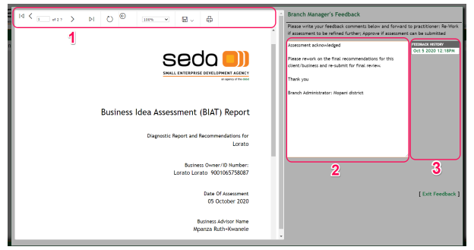

If the verdict of the review was “Approved”, the user will also receive an email from the tools system to the same effect, as indicated below:

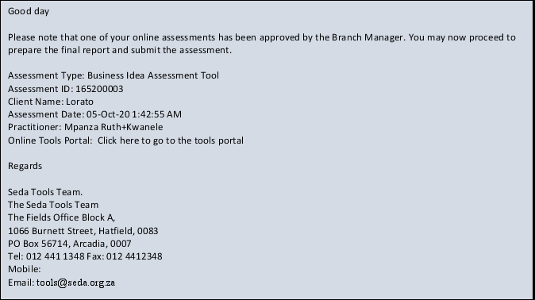

1. At this point, the assessment will be ready to upload Final Report, which is explained in the next stage.

## Uploading the Final Report

Once the assessment has been approved by the B/A, the assessment will replace the “Review/Submit Assessment” panel with the “Final Report” panel, as show below:

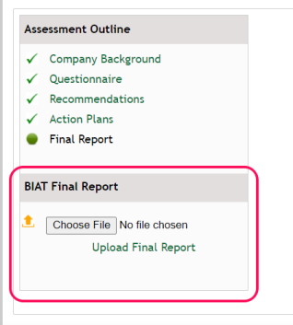

**Follow the procedure below to process and upload the final report:**

1. Click on the “Online Report” link. This will display the current online report of the assessment
2. Click on the “disk” icon and select PDF

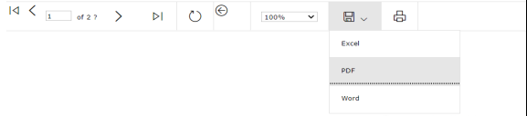

1. The report will be downloaded to the default download path on your local machine
2. Print the and send the report for signing by all involved authorities (Business Advisor/Practitioner, Branch Administrator, Client)
3. Scan-to-file the signed report into a folder on your machine
4. On the “Final Report” panel, click on “Choose File” button. This will display the file-dialog popup box
5. Select the signed, scanned final report
6. Back on the Final Report panel, click on the “Upload Final Report”
7. The final report will be saved and the link will read “Upload Final Report (Report Saved)”

## Submitting the Final Report

1. Once report is uploaded, the following happens:
2. Final Report link will also have a green tick, indicating that the final report has been uploaded
3. The Submit button will reappear with a “Submit Assessment” caption, indicating the assessment can now be closed

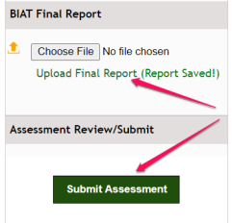

1. Click on the “Submit Assessment” link.
2. A popup dialog message will appear on the screen for the user to confirm if they are really sure they need to close the assessment:

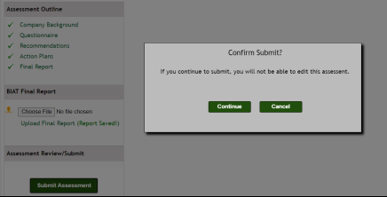

1. Click “Continue” if you are really certain you need to submit the assessment and close it
2. Once the above is done, the following will happen:
3. The report will indicate that it has been submitted as indicated below:

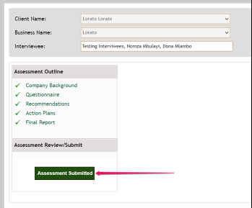

1. On the assessment’s home-page, the status of the assessment change to “Complete”, as show below:

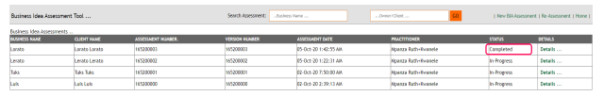

# Individual Assessments

In this section we run through each assessment that is currently active on the Seda tools’ portal.

Most of the processes have been explained, so we will detail only unique sections for some of the tools, that are not common in the other tools.

## Business Idea Assessment Tool (BIA)

The BIAT is a simple straight-forward tool to use. We briefly outline the processes involved below.

1. Log into the tools’ portal
2. From the tools home-page (or from menu items), click on the Business Idea Assessments option

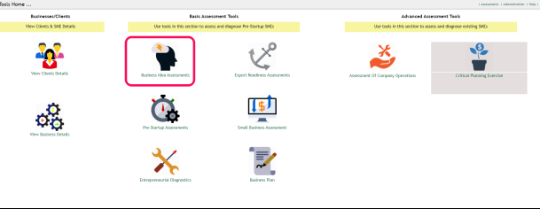

1. On selecting the BIAT option, the system will navigate to the BIAT home-page. On the BIAT home page, user can do the following:

- Start a new BIAT assessment (click “New BI Assessment” link marked 1)

- List all previous BIAT assessments for current user

- Search for previous BIAT assessment (marked 3)

- Drill-down to a registered BIAT assessment (click “Details ..” link column marked 4)

- Go back to the tools’ home-page indicated by link “Home”

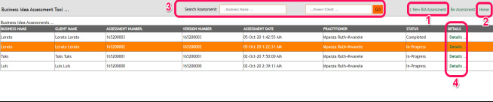

## Carrying out a BIAT assessment

1. From the BIAT home page, click on the “New BI Assessment”, the system will navigate to the BIAT assessment page as shown. Initially this will show the assessment-identity section, where user will register the assessment

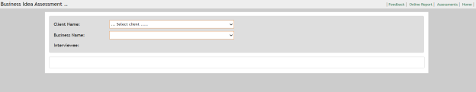

1. Select the Client name from the dropdown list. All the businesses registered under the selected client will appear in the Business Name dropdown list
2. Select the business to be assessed
3. Enter full names of the interviewees
4. Click the “Create Assessment” button to register the assessment. If the registration was successful, the details section of the assessment will show up at the bottom of the current form

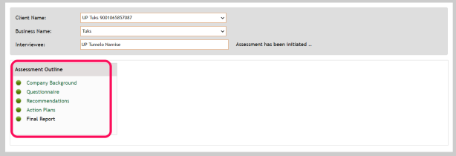

1. Complete the following sections as explained in the sections above:
   * Company Background
   * Questionnaire
   * Recommendations
   * Action Plans
2. Once the above sections are complete, the assessment is ready to be submitted to the Branch Manager for a review. This process can be repeated until the assessment contains satisfactory information that can be useful enough to advise the client.

To submit the assessment, use the button that shows up under the new panel that shows up.

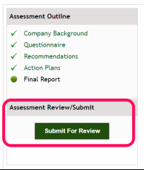

1. Click “Submit For Review” to submit the assessment. The system will send an email notification to the Branch manager about the pending review
2. After Branch manager submits a review, the user will receive an email notification that the assessment has been reviewed
3. Log into the tools and navigate to the assessment. Click on the “Feedback” link to see the review message from the Branch Manager.
4. If the assessment has been approved, the final report will need to be prepared and uploaded.
5. Click on the “Online Report” link to download the current online report

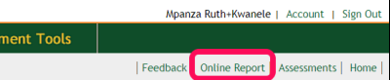

1. Download the online report by clicking on the floppy-disk icon, then select “PDF” to export to .PDF format.

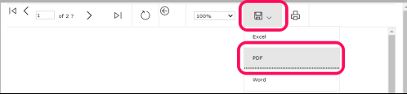

Also note here that you can directly print the report by clicking the printer icon next to the disk in the illustration above

1. Process the report, and scan to file
2. On the “BIA Final Report” menu (shown below), click on the “choose file” button to display the file-dialog bog’
3. Select the scanned final report, click the “Upload Final Report” link. This will upload the final report to the assessment
4. Notice here that the “Final Report” section link will also be ticked to indicate that the final report has been uploaded.

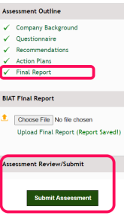

1. The “Review/Submit Assessment” panel re-appears at the bottom of the sections pane, with a “Submit Assessment” button.
2. Click on the “Submit Assessment” button to close the assessment. The following confirmation popup will appear.

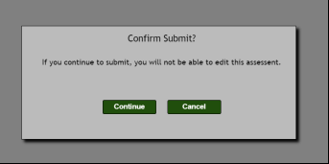

1. Select “Continue” to proceed submitting the assessment.
2. If the submit was successful, the outline pane should look like below:

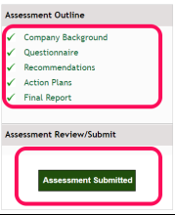

1. On the BIAT home-page, the status of the assessment should also change from “In Progress” to complete



1. This is the end of the assessment process

## The Pre-Startup Assessment Tool (PST)

Follow the processes below to complete the Pre-Startup assessment for a business.

1. Log into the tools’ portal
2. From the tools home-page (or from menu items), click on the Pre-Startup Assessments

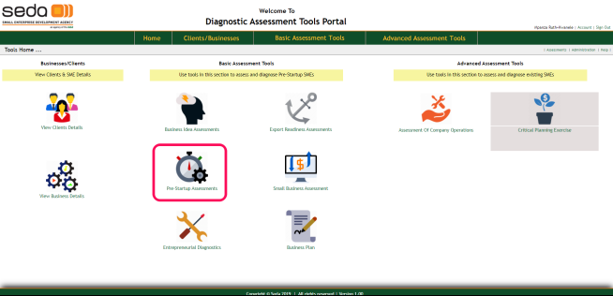

1. On selecting the PST option, the system will navigate to the PST home-page. On the PST home page, user can do the following:

- Start a new PST assessment (click “New PST Assessment” link marked 1)

- List all previous PST assessments for current user (default view)

- Search for previous PST assessment (marked 3)

- Drill-down to a registered PST assessment (click “Details ..” link column marked 4)

- Go back to the tools’ home-page click “Home” link marked 4)

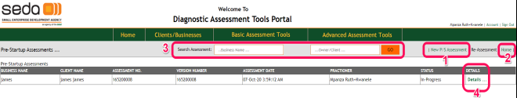

## Carrying out a PST assessment

1. From the PST home page, click on the “New PST Assessment”, the system will navigate to the PST assessment page as shown. Initially this will show the assessment-identity section, where user will register the assessment

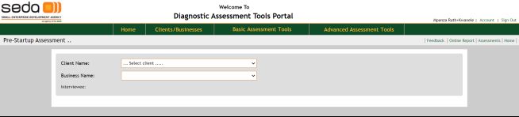

1. Select the Client name from the dropdown list. All the businesses registered under the selected client will appear in the Business Name dropdown list
2. Select the business to be assessed
3. Enter full names of the interviewees
4. Click the “Create Assessment” button to register the assessment. If the registration was successful, the details section of the assessment will show up at the bottom of the current form

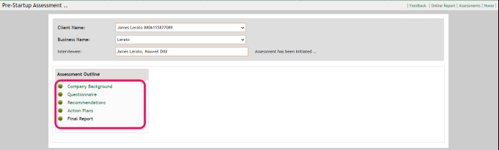

1. Complete the following sections as explained in the sample assessment above:

- Company Background

- Questionnaire

- Recommendations

- Action Plans

1. Once the above sections are complete, the assessment is ready to be submitted to the Branch Manager for a review.

This process can be repeated until the assessment contains satisfactory information that can be useful enough to advise the client.

1. To submit the assessment, use the button that shows up under the new panel that shows up.



1. Click “Submit For Review” to submit the assessment. The system will send an email notification to the Branch manager about the pending review
2. After Branch manager submits a review, the user will receive an email notification that the assessment has been reviewed
3. Log into the tools and navigate to the assessment. Click on the “Feedback” link to see the review message from the Branch Manager.
4. If the assessment has been approved, the final report will need to be prepared and uploaded.
5. Click on the “Online Report” link to download the current online report



1. Download the online report by clicking on the floppy-disk icon, then select “PDF” to export to .PDF format.



Also note here that you can directly print the report by clicking the printer icon next to the disk in the illustration above

1. Process the report, and scan to file
2. On the “Final Report” menu (shown below), click on the “choose file” button to display the file-dialog bog’
3. Select the scanned final report, click the “Upload Final Report” link. This will upload the final report to the assessment
4. Notice here that the “Final Report” section link will also be ticked to indicate that the final report has been uploaded.



1. The “Review/Submit Assessment” panel re-appears at the bottom of the sections pane, with a “Submit Assessment” button.
2. Click on the “Submit Assessment” button to close the assessment. The following confirmation popup will appear.



1. Select “Continue” to proceed submitting the assessment.
2. If the submit was successful, the outline pane should look like below:

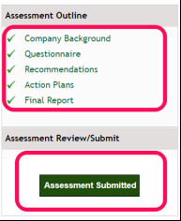

1. On the PST home-page, the status of the assessment should also change from “In Progress” to complete
2. This is the end of the assessment process

## The Entrepreneurial Diagnostic Tool (EDT)

The EDT is a simple straight-forward tool to use. We briefly outline the processes involved below.

1. Log into the tools’ portal
2. From the tools home-page (or from menu items), click on the Business Idea Assessments option

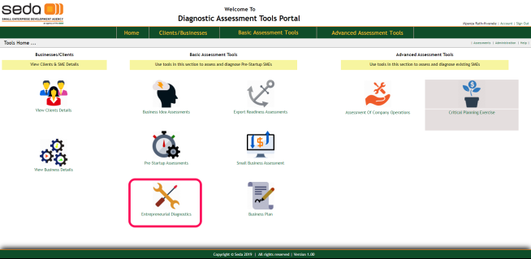

1. On selecting the EDT option, the system will navigate to the EDT home-page. On the EDT home page, user can do the following:

- Start a new EDT assessment (click “New EDT Assessment” link marked 1)

- List all previous EDT assessments for current user

- Search for previous EDT assessment (marked 3)

- Drill-down to a registered EDT assessment (click “Details ..” link column marked 4)

- Go back to the tools’ home-page indicated by link “Home”

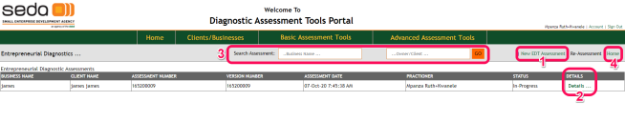

## Carrying out an EDT assessment

1. From the EDT home page, click on the “New BI Assessment”, the system will navigate to the EDT assessment page as shown. Initially this will show the assessment-identity section, where user will register the assessment

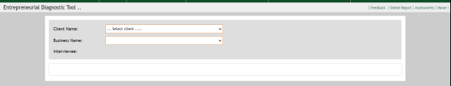

1. Select the Client name from the dropdown list. All the businesses registered under the selected client will appear in the Business Name dropdown list
2. Select the business to be assessed
3. Enter full names of the interviewees
4. Click the “Create Assessment” button to register the assessment. If the registration was successful, the details section of the assessment will show up at the bottom of the current form

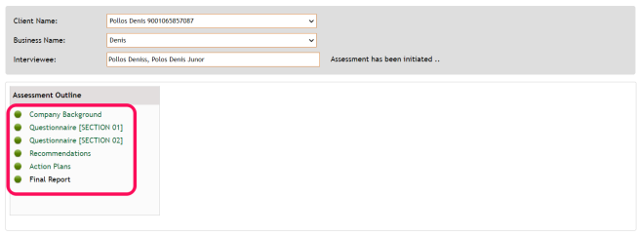

1. Complete the following sections as explained in the sections above:

- Company Background

- Questionnaire SECTION1 and Questionnaire SECTION 2

- Recommendations

- Action Plans

1. Once the above sections are complete, the assessment is ready to be submitted to the Branch Manager for a review. This process can be repeated until the assessment contains satisfactory information that can be useful enough to advise the client.
2. To submit the assessment, use the button that shows up under the new panel that shows up.

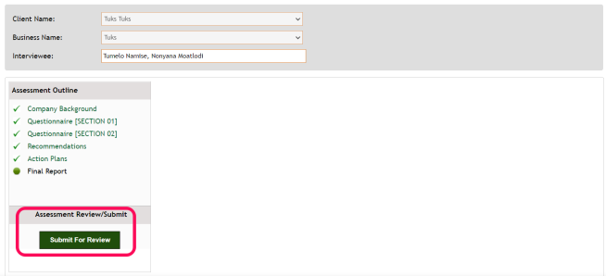

1. Click “Submit For Review” to submit the assessment. The system will send an email notification to the Branch manager about the pending review
2. After Branch manager submits a review, the user will receive an email notification that the assessment has been reviewed
3. Log into the tools and navigate to the assessment. Click on the “Feedback” link to see the review message from the Branch Manager.
4. If the assessment has been approved, the final report will need to be prepared and uploaded.
5. Click on the “Online Report” link to download the current online report



1. Download the online report by clicking on the floppy-disk icon, then select “PDF” to export to .PDF format.



Also note here that you can directly print the report by clicking the printer icon next to the disk in the illustration above

1. Process the report, and scan to file
2. On the “BIA Final Report” menu (shown below), click on the “choose file” button to display the file-dialog bog’
3. Select the scanned final report, click the “Upload Final Report” link. This will upload the final report to the assessment
4. Notice here that the “Final Report” section link will also be ticked to indicate that the final report has been uploaded.



1. The “Review/Submit Assessment” panel re-appears at the bottom of the sections pane, with a “Submit Assessment” button.
2. Click on the “Submit Assessment” button to close the assessment. The following confirmation popup will appear.



1. Select “Continue” to proceed submitting the assessment.
2. If the submit was successful, the outline pane should look like below:



1. On the EDT home-page, the status of the assessment should also change from “In Progress” to complete
2. This is the end of the assessment process

## Export Readiness Assessment Tool (ERAT)

To perform an ERAT assessment follow the steps bellow.

1. Log into the tools’ portal
2. From the tools home-page (or from menu items), click on the Export Readiness Assessments option as indicated in the illustration below.

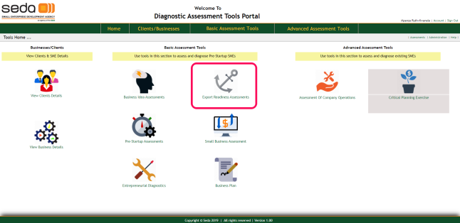

1. On selecting the ERAT option, the system will navigate to the ERAT home-page. On the ERAT home page, user can do the following:

- Start a new ERAT assessment (click “New BI Assessment” link marked 1)

- List all previous ERAT assessments for current user

- Search for previous ERAT assessment (marked 3)

- Drill-down to a registered ERAT assessment (click “Details ..” link column marked 2)

- Go back to the tools’ home-page indicated by link “Home” (4)

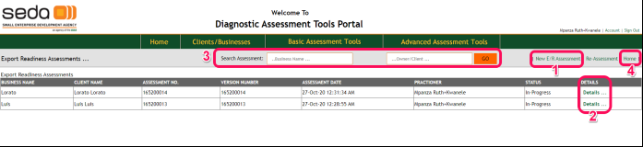

## Carrying out an ERAT assessment

1. From the ERAT home page, click on the “New BI Assessment”, the system will navigate to the ERAT assessment page as shown. Initially this will show the assessment-identity section, where user will register the assessment

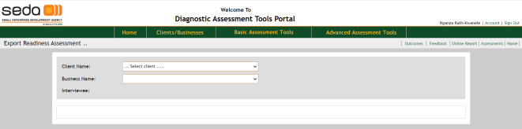

1. Select the Client name from the dropdown list. All the businesses registered under the selected client will appear in the Business Name dropdown list
2. Select the business to be assessed
3. Enter full names of the interviewees
4. Click the “Create Assessment” button to register the assessment. If the registration was successful, the details section of the assessment will show up at the bottom of the current form

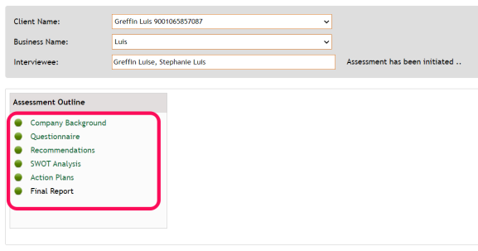

1. Complete the following sections as explained in the sections above:

- Company Background

- Questionnaire

- Recommendations

- Action Plans

1. Once the above sections are complete, the assessment is ready to be submitted to the Branch Manager for a review. This process can be repeated until the assessment contains satisfactory information that can be useful enough to advise the client.
2. To submit the assessment, use the button that shows up under the new panel that shows up.



1. Click “Submit For Review” to submit the assessment. The system will send an email notification to the Branch manager about the pending review
2. After Branch manager submits a review, the user will receive an email notification that the assessment has been reviewed
3. Log into the tools and navigate to the assessment. Click on the “Feedback” link to see the review message from the Branch Manager.
4. If the assessment has been approved, the final report will need to be prepared and uploaded.
5. Click on the “Online Report” link to download the current online report



1. Download the online report by clicking on the floppy-disk icon, then select “PDF” to export to .PDF format.



Also note here that you can directly print the report by clicking the printer icon next to the disk in the illustration above

1. Process the report, and scan to file
2. On the “BIA Final Report” menu (shown below), click on the “choose file” button to display the file-dialog bog’
3. Select the scanned final report, click the “Upload Final Report” link. This will upload the final report to the assessment
4. Notice here that the “Final Report” section link will also be ticked to indicate that the final report has been uploaded.



1. The “Review/Submit Assessment” panel re-appears at the bottom of the sections pane, with a “Submit Assessment” button.
2. Click on the “Submit Assessment” button to close the assessment. The following confirmation popup will appear.



1. Select “Continue” to proceed submitting the assessment.
2. If the submit was successful, the outline pane should look like below:



1. On the ERAT home-page, the status of the assessment should also change from “In Progress” to complete
2. This is the end of the assessment process

## Small Business Assessment Tool (SBAT)

The Small Business Assessment tool is also a simple to use tool. To perform an SBAT assessment, follow the procedures explained below.

1. Log into the tools’ portal
2. From the tools home-page (or from menu items), click on the Small Business Assessments option, as indicated in the illustration below:

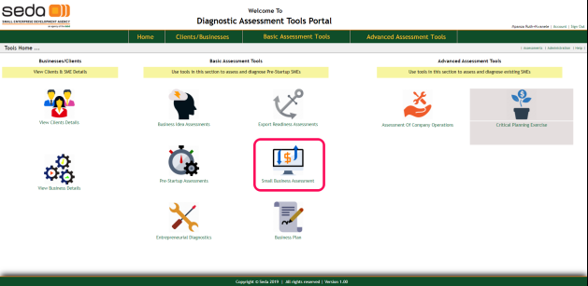

1. On selecting the SBAT option, the system will navigate to the SBAT home-page. On the SBAT home page, user can do the following:

- Start a new SBAT assessment (click “New S/B Assessment” link marked 1)

- List all previous SBAT assessments for current user

- Search for previous SBAT assessment (marked 3)

- Drill-down to a registered SBAT assessment (click “Details ..” link column marked 2)

- Go back to the tools’ home-page indicated by link “Home” (Indicated 4)

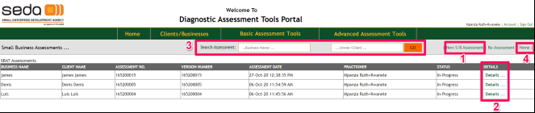

## Carrying out a SBAT assessment

1. From the SBAT home page, click on the “New S/B Assessment”, the system will navigate to the SBAT assessment page as shown. Initially this will show the assessment-identity section, where user will register the assessment

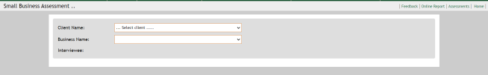

1. Select the Client name from the dropdown list. All the businesses registered under the selected client will appear in the Business Name dropdown list
2. Select the business to be assessed
3. Enter full names of the interviewees
4. Click the “Create Assessment” button to register the assessment. If the registration was successful, the details section of the assessment will show up at the bottom of the current form

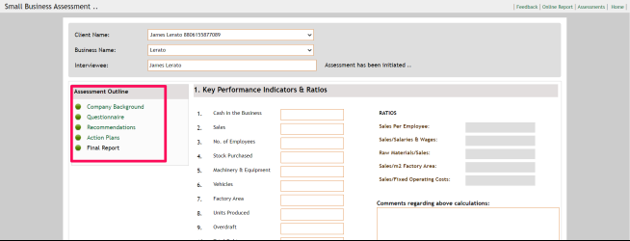

1. Complete the following sections as explained in the sections above:

- Company Background

- Questionnaire

- Recommendations

- Action Plans

1. Once the above sections are complete, the assessment is ready to be submitted to the Branch Manager for a review. This process can be repeated until the assessment contains satisfactory information that can be useful enough to advise the client.
2. To submit the assessment, use the button that shows up under the new panel that shows up.



1. Click “Submit For Review” to submit the assessment. The system will send an email notification to the Branch manager about the pending review
2. After Branch manager submits a review, the user will receive an email notification that the assessment has been reviewed
3. Log into the tools and navigate to the assessment. Click on the “Feedback” link to see the review message from the Branch Manager.
4. If the assessment has been approved, the final report will need to be prepared and uploaded.
5. Click on the “Online Report” link to download the current online report



1. Download the online report by clicking on the floppy-disk icon, then select “PDF” to export to .PDF format.

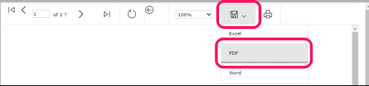

Also note here that you can directly print the report by clicking the printer icon next to the disk in the illustration above

1. Process the report, and scan to file
2. On the “BIA Final Report” menu (shown below), click on the “choose file” button to display the file-dialog bog’
3. Select the scanned final report, click the “Upload Final Report” link. This will upload the final report to the assessment
4. Notice here that the “Final Report” section link will also be ticked to indicate that the final report has been uploaded.



1. The “Review/Submit Assessment” panel re-appears at the bottom of the sections pane, with a “Submit Assessment” button.
2. Click on the “Submit Assessment” button to close the assessment. The following confirmation popup will appear.



1. Select “Continue” to proceed submitting the assessment.
2. If the submit was successful, the outline pane should look like below:



1. On the SBAT home-page, the status of the assessment should also change from “In Progress” to complete
2. This is the end of the assessment process

## Assessment Of Company Operations (ACO)

The ACO is an advanced, comprehensive tool that requires more dedication from the practitioner and the interviewee/s. Below is a summary of the procedures to carrying out an ACO assessment.

1. Log into the tools’ portal
2. From the tools home-page (or from menu items), click on the Assessment Of Company Operations icon/option, as indicated in the illustration below.

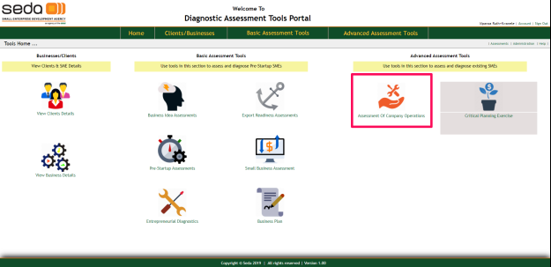

1. On selecting the ACO option, the system will navigate to the ACO home-page. On the ACO home page, user can do the following:

- Start a new ACO assessment (click “New ACO Assessment” link marked 1)

- List all previous ACO assessments for current user

- Search for previous ACO assessment (marked 3)

- Drill-down to a registered ACO assessment (click “Details ..” link column marked 2)

- Go back to the tools’ home-page indicated by link “Home” – indicated 4

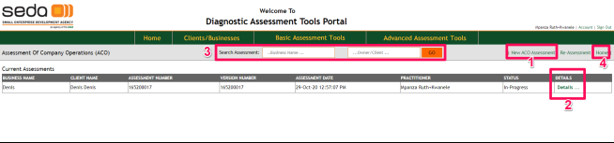

## Carrying out an ACO assessment

1. From the ACO home page, click on the “New ACO Assessment”, the system will navigate to the ACO assessment page as shown. Initially this will show the assessment-identity section, where user will register the assessment

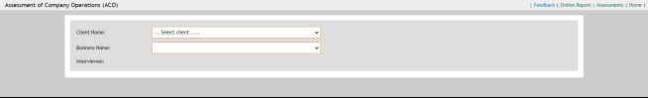

1. Select the Client name from the dropdown list. All the businesses registered under the selected client will appear in the Business Name dropdown list
2. Select the business to be assessed
3. Enter full names of the interviewees
4. Click the “Create Assessment” button to register the assessment. If the registration was successful, the details section of the assessment will show up at the bottom of the current form

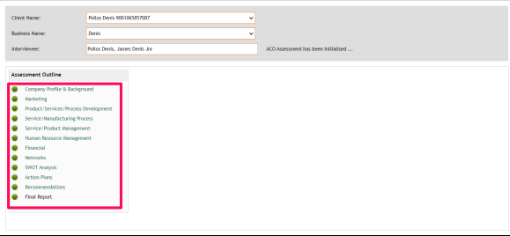

1. Complete the following sections as explained in the sections above:

- Company Background

- Questionnaire

- Recommendations

- Action Plans

1. Once the above sections are complete, the assessment is ready to be submitted to the Branch Manager for a review. This process can be repeated until the assessment contains satisfactory information that can be useful enough to advise the client.
2. To submit the assessment, use the button that shows up under the new panel that shows up.

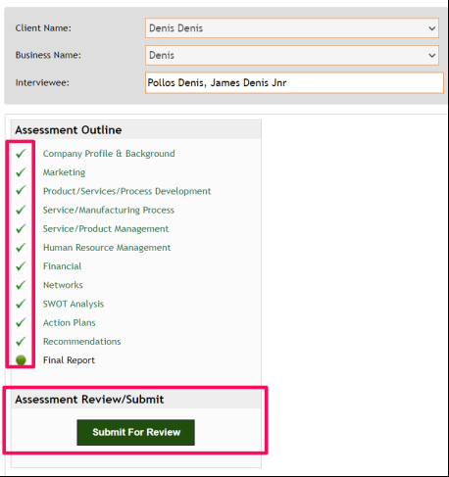

1. Click “Submit For Review” to submit the assessment. The system will send an email notification to the Branch manager about the pending review
2. After Branch manager submits a review, the user will receive an email notification that the assessment has been reviewed
3. Log into the tools and navigate to the assessment. Click on the “Feedback” link to see the review message from the Branch Manager.
4. If the assessment has been approved, the final report will need to be prepared and uploaded.
5. Click on the “Online Report” link to download the current online report



1. Download the online report by clicking on the floppy-disk icon, then select “PDF” to export to .PDF format.



Also note here that you can directly print the report by clicking the printer icon next to the disk in the illustration above

1. Process the report, and scan o file
2. On the “BIA Final Report” menu (shown below), click on the “choose file” button to display the file-dialog bog’
3. Select the scanned final report, click the “Upload Final Report” link. This will upload the final report to the assessment
4. Notice here that the “Final Report” section link will also be ticked to indicate that the final report has been uploaded.

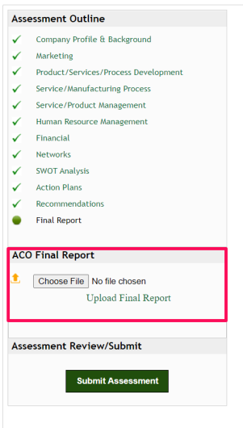

1. The “Review/Submit Assessment” panel re-appears at the bottom of the sections pane, with a “Submit Assessment” button.
2. Click on the “Submit Assessment” button to close the assessment. The following confirmation popup will appear.



1. Select “Continue” to proceed submitting the assessment.
2. If the submit was successful, the outline pane should look like below:

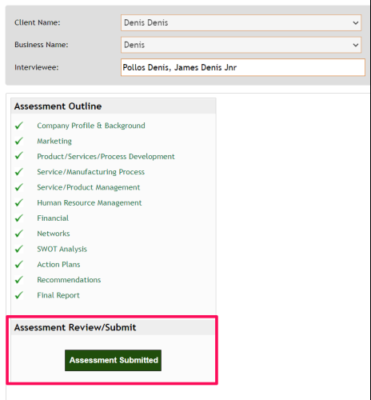

1. On the ACO home-page, the status of the assessment should also change from “In Progress” to “Completed” as indicated in the illustration below:

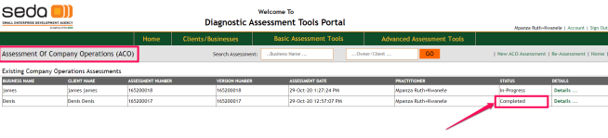

1. This is the end of the assessment process for the ACO.